Northern Ireland: Catholic and Protestant Conflict
Learning intentions:
- Understand how the actions of James I, Charles I, and Cromwell planted the seeds for future hostilities in Ireland between Protestants and Catholics.
- Explore how the conflict has grown and changed in years since
- Investigate the current situation in Ireland
Map
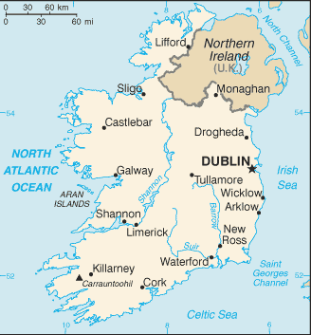
Ireland is on the western coast of England. It is separated from Wales, England, and Scotland by the Celtic Sea, the Irish Sea, and the North Channel.
Conflict between England and Ireland has existed for centuries.
Currently it is divided into the Free Republic of Ireland and Northern Ireland, which is still a part of the United Kingdom.
Many wars and battles have been fought for Ireland to gain independence and recognition. There still are unsettled issues, especially in Northern Ireland where tensions between Catholics and Protestants remain strong.
James I was hoped to be, by all Catholics, much more sympathetic to their cause as his mother was a staunch Catholic herself.
However, James I did not alter any laws prohibiting the practice of the Catholic religion. In addition, he continued to send Protestants and Presbyterians to lands confiscated from the Irish (Ulster and Munster most heavily) to start settlements and plantations.
The Irish Catholic upper classes were unable to stop the continued plantations in Ireland because they had been barred from public office because of their religion and had become a minority in the Irish Parliament by 1615, as a result of the creation of "pocket boroughs" (where Protestants were in the majority) in planted areas. However, they managed to temporarily halt land confiscations in 1625, by agreeing to pay for England’s war with France and Spain.

1641 Irish Rebellion
- Started by Phelim O’Neill, it aimed to correct multiple complaints of the Irish Catholic landowners.
- The rebellion quickly boiled over in Ulster, where native Irish began attacking the settler population.
- The rebellion caused the death of approximately 4,000 settlers directly, and another 12,000 through disease or poverty after being removed from their homes.
- Confederate Ireland, with their own government, negotiated with Charles I the end to the plantations and religious tolerance.
Charles I tried for support from Ireland when facing the Parliamentarian and New Model Armies. His sympathy and cooperation with the Irish would be judged as treacherous in the eyes of the English Parliament.

Cromwell and the Irish
Since it was not the Royalist Army who won the British Civil War, Ireland had to deal with Oliver Cromwell.
Cromwell held ALL Irish Catholics responsible for the Rebellion of 1641. He dealt with them swiftly and brutally – executions, massacres, and land seizures. 12,000 members of the New Model Army were planted into Ireland – land being theirs in place of wages. Of the 12,000 that were given land, 7,500 stayed, the rest sold their land to other Protestants.
Most of these were single men however and many of them married Irish women (although banned by law from doing so). Some of the Cromwellian soldiers therefore became integrated into Irish Catholic society. In addition to the Parliamentarians, thousands of Scottish Covenanter soldiers, who had been stationed in Ulster during the war settled there permanently after its end.
A land-owning class of British Protestants was created to rule over Irish Catholic tenants. A minority of the "Cromwellian" landowners were actually Parliamentarian soldiers or creditors. Most landowners were pre-war Protestant settlers, who grabbed the opportunity to acquire seized lands. Before the Civil War, Catholics had owned 60% of the land in Ireland. During the Commonwealth Catholics owned 8-9% and after some restitution in the Restoration Act of Settlement 1662, it rose to 20% again.

Long-term results
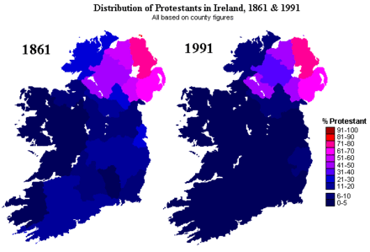
The Plantations had a profound impact on Ireland in several ways. The first was the destruction of the native ruling classes and their replacement with the Protestant Ascendancy, of British-origin (mostly English) Protestant landowners. Their position was supported by the Penal Laws, which refused political and most land-owning rights to Catholics and to a certain degree to Presbyterians. The dominance of this class in Irish life persisted until the late 18th century, and it voted for the Act of Union with Britain in 1800.
The current division of Ireland into the Republic of Ireland and Northern Ireland is largely caused by the settlement patterns of the Plantations of the 1600s.
The descendants of the British Protestant settlers enjoy being linked with Britain, whereas the descendants of the native Irish Catholics wanted Irish independence.
By 1922, Unionists were in the majority in four of the nine counties of Ulster. Consequently, following the Anglo-Irish settlement of 1921, these four counties – and two others in which they formed a sizeable minority – remained in the United Kingdom to form Northern Ireland. This new state contained a sizable Catholic minority, many of whom claimed to be descendants of those dispossessed in the Plantations.
The Troubles in Northern Ireland are therefore in some respects a continuation of the conflict arising from the plantations.

The Irish Question:
What was the state of Ireland in terms of political organization prior to the invasion of the Normans?

Who were the first English Kings to try to dominate and subject Ireland? Why did they?

What was the purpose of the Plantations? Where were they?

What was the 9 yrs war?

What role did James I and Charles I play in increasing hostilities there?

What was the revolt of 1641?

Summarize what Cromwell did in Ireland. Explain the Adventurers Act.

Who is Henry Grattan?

What did Daniel O’Connell do?

How did the great Famine affect the rising revolts?

Who are the Finians? Do they still exist today?

What is Home Rule? Where was it least popular and why? Who are the Unionists?

What is Sinn Fein? Who are the IRB?

What was the Easter Rising? What were its effects?

Who were the IRA? The Black & Tans?

What was the Government of Ireland Act?

Did the separation of Free Irish Republic from Northern Ireland stop the conflict?

Find an article from Ireland during the 1980s-1990s about an incident of conflict? Find a corresponding article from somewhere else in the world. Compare the points of view.

