English Civil War:
Charles has fled to the North. London is under the control of Parliament. Let us recap some of the significant events and the major players. Use databases like Britannica on-line and websites like the BBC and your text book to create full, well-rounded answers.
Who were the
Roundheads
Cavaliers
The Covenanters
The Levellers

What areas of England did Charles I draw support from?
What areas of England did Parliament get its support from?
What was significant about the battles of Marston Moor and Naseby?
True or false, there was only one British Civil War? Explain.
What was significant about The New Model Army? Who was responsible for it?
What was the Engagement between the Covenanters and Charles?
Why did Charles I turn himself over to the Scottish?
What was the Rump Parliament? Would you consider it successful or disgraceful parliament? What were some of the arguments being discussed during the Rump?
What was the Pride’s Purge? What was its outcome?

Look at these Political Broadsides. Discuss with your group members what they are trying to convey.
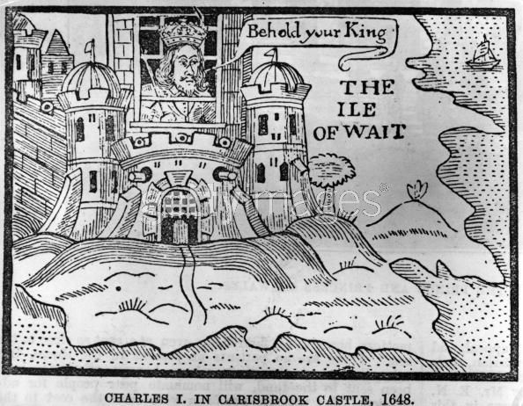
Find out the history of what is going on in the picture. Discuss why it is a poignant piece

Who would have published this? Who are they trying to get support against?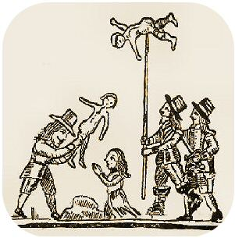

How is Cromwell and his working with Parliament like classroom “group work”?

When is good done through bad?

