PBS: The Medici God Fathers of the Renaissance
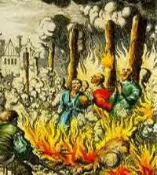
In 1545, the leaders of the Catholic Church gathered in the Northern Italian city of Trent for an emergency conference. Their aim was to reclaim the moral high ground, and the superiority of the Holy Mother Church, in the wake of the Protestant challenge. The stakes were high. They were playing for the survival of the Roman Catholic Church.
After on and off for 20-years of debate, the Council of Trent established the basis for a Catholic counter-attack. Decrees were issued covering every aspect of Church authority, from the holding of multiple offices, to the chastity of priests, and monastic reform. Ignatius Loyola was charged with forming the Jesuits, a band of militant missionaries whose task was to reconvert the converted.
The “Index of Forbidden Books” was published, naming and shaming 583 heretical texts, including most translations of the Bible and the works of Erasmus, Calvin and Luther. New churches were ordered to be built, with space for thousands of worshippers, and acoustics designed, for the first time, for vernacular sermons. The Catholic Church used the weapon of reform to entice back its disillusioned congregations.
A new agency of obedience was created. Taking its cue from a successful. Spanish model, the Council of Trent formally established the Roman Inquisition, to examine and try all evidence of heresy or dissent. No Catholic country was exempt. All crimes in the eyes of the Church would be handed to a local Inquisitor, equipped with all necessary means of persuasion. Guilt was always assumed, interrogation relentless, and torture deployed to squeeze the truth out of a witness.
Encyclopedia Britannica
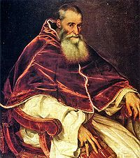
There was very little reaction from within the Roman Catholic Church before the mid-16th century in terms of listening to the demands of reform from the Protestants and others. Their initial reaction was to simply excommunicate those who opposed them. However, to stem the tide of followers jumping ship, Pope Paul III (reigned 1534–49) who is considered to be the first pope of the Counter-Reformation, convened the Council of Trent in 1545. The council met on and off until 1563, when it responded emphatically to the issues at hand. Its doctrinal teaching was a reaction against the Lutheran emphasis on the role of faith and God’s grace. The teaching also stood firm against the Protestant teachings on the number and nature of the sacraments. Disciplinary reforms attacked the corruption of the clergy. There was an attempt to regulate the training of candidates for the priesthood; measures were taken against luxurious living on the part of the clergy, the appointment of relatives to church office, and the absence of bishops from their dioceses. Prescriptions were given about pastoral care and the administration of the sacraments.
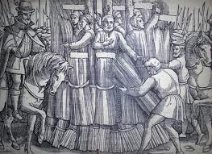
Another conclusion that came from The Council of Trent was the establishment of the Roman Inquisition, an agency created in 1542 to combat heresy. This agency was more successful in controlling doctrine and practice in Italy than similar bodies in those countries where Protestant princes had more power than the Roman Catholic Church. Political and military involvement directed against Protestant growth is most clearly reflected in the policies of Emperor Charles V and in those of his son Philip II, who was associated with the Spanish Inquisition.

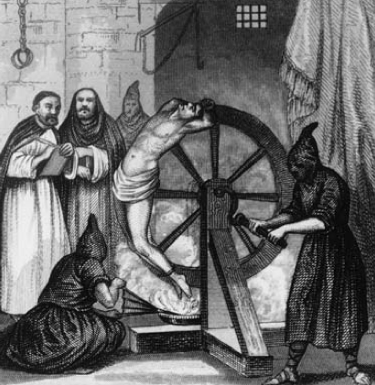
Various theologians—especially the Jesuit Robert Bellarmine—attacked the doctrinal positions of the Reformers, however there was no one to rival the theological and moral engagement evident in the writings of Luther or the eloquence and passion characteristic of the works of John Calvin. Roman Catholics tended to emphasize the beliefs and devotional subjects that were under direct attack by the Protestants—e.g., the Real Presence of Christ in the Eucharist, the Virgin Mary, and St. Peter.
A major emphasis of the Counter-Reformation was an ongoing missionary endeavour in parts of the world that had been colonized by predominantly Roman Catholic countries. The work of such men as Francis Xavier and others in Asia and of missionaries in the New World was rewarded with millions of baptisms, if not true conversions. There were also attempts to reconvert areas of the world that had once been Roman Catholic—e.g., England and Sweden.
Using information from both sources answer the following questions
- What issues did the Catholic Church address internally to improve its outward appearance? In other words, where did they seek reform?
- What measures did the Catholic Church take to stop the spreading of Protestant faith? What was the purpose of the Inquisitions?
- What issues did the Catholic Church see as the biggest flaws in Protestant faith?
- Why does the second article say “The work of such men as Francis Xavier and others in Asia and of missionaries in the New World was rewarded with millions of baptisms, if not true conversions.”? What is important about missionary work?

