French Revolution
Assignment 2 part 1
Crossroads 188-199
- Terms: Define each of the following terms (12)
Terms | Definition
Feudal system
Philosophes
Absolute monarchy
Democracy
Tithe
Artisan
Inflation
Monopoly
Tariff
Toll
Infrastructure
Cash crop

B. The Regions of France
1. Read pages 200-201 and study the maps in France. What characteristics allow it to grow a variety of crops? List four characteristics (4)
____________________________________________________________________________________________________________________________________________________________________________________________________________________________________________________________________________________________________________________________________________________
2. List the agricultural activities and crops in France. (5)
____________________________________________________________________________________________________________________________________________________________________________________________________________________________________________________________________________________________________________________________________________________
3. Briefly describe the lives of peasants who lived in the wine-producing regions of France. (3)
____________________________________________________________________________________________________________________________________________________________________________________________________________________________________________________________________________________________________________________________________________________
4. Was city life better or worse than the life of someone living in the countryside? (2)
____________________________________________________________________________________________________________________________________________________________________________________________________________________________________________________________________________________________________________________________________________________
5. Why are the Bourgeoisie a division in the third estate, different than the others? How do you see their role coming to the forefront in French politics in as the Revolution begins? (4)
________________________________________________________________________________________________________________________________________________________________________________________________________________________________________________________________________________________________________________________________________________________________________________________________________________________________________________________________________________________________________________________________________________________________________________________________________________________________________________________________________________________________________

C. French Society in the 17th Century
1. Complete the triangle diagram below by describing each segment of the French society (12)
French Monarchy
Church officials

Aristocrats
Peasants
Bourgeoisie
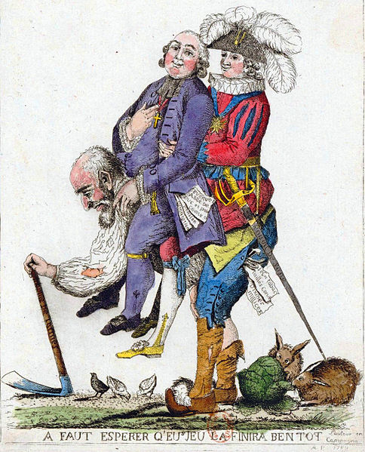
D. After reading the power point and the section in the textbook, apply what you have learned to explain what is happening in the painting. Look at the different symbols, characters, and words to complete your answer. (5)

